LAPORAN PRAKTIKUM PENGOLAHAN CITRA DIGITAL
22. FEATURE EXTRACTION AND REPRESENTATION


Disusun oleh :
Nama : Felix
NPM : 2327250059
Kelas : IF41

PROGRAM STUDI INFORMATIKA
FAKULTAS ILMU KOMPUTER DAN REKAYASA
UNIVERSITAS MULTI DATA PALEMBANG
2024

TUTORIAL : FEATURE EXTRACTION AND REPRESENTATION

Goal
The goal of this tutorial is to learn how to use MATLAB to extract features from binary images and use these features to recognize objects within the image.

Objectives
- Learn how to use the regionprops function to extract features from binary objects.
- Learn how to perform feature selection and use the selected features to implement a simple, application-specific, heuristic classifier.

What You Will Need
- Test images TPTest1.png, shapes23.png, and Test3.png.

Procedure
We will start by exploring the rgb2hsv function.
- Load test image TPTest1.png (Figure 22.1(a)) and display its contents.
FIGURE 22.1 Test images for this tutorial: (a) steps 1–6; (b) step 7; (c) step 11.

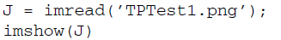
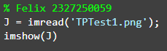
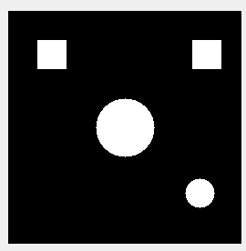

- Use bwboundaries to display the boundaries of the objects in the test image.
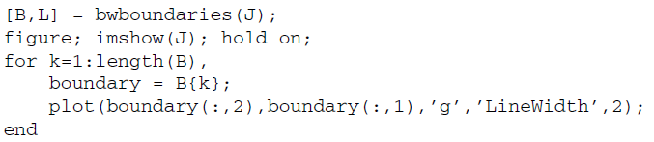
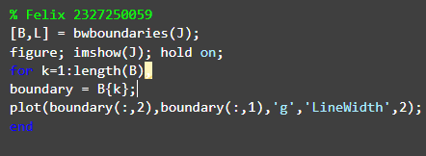
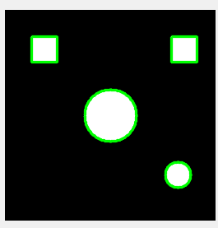

- Use bwlabel to label the connected regions (i.e., objects) in the test image, pseudocolor them, and display each of them with an associated numerical label.
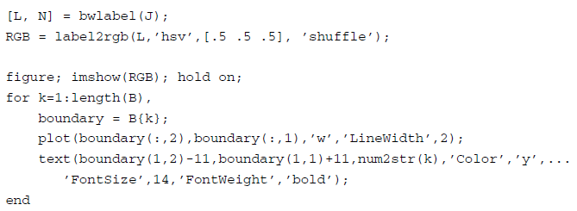
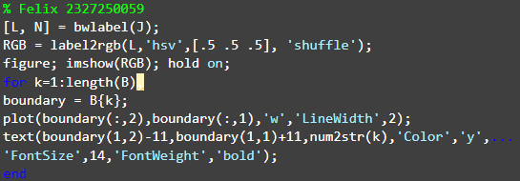
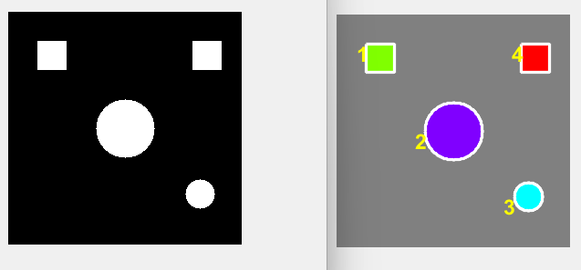

Question 1 What is the value of N returned by bwlabel? Does it make sense to you?
Nilai yang di kembalikan oleh N adalah 4, menurut saya masuk akal karena pada gambar tersebut memiliki 4 buah objek putih pada gambar.

- Use regionprops to extract the following binary features for each object in the image (top left square, top right square, small circle, big circle): area, centroid, orientation, Euler number, eccentricity, aspect ratio, perimeter, and thinness ratio.
- Organize the feature values and object names in a table (see Table 22.1), for easier comparative analysis.

TABLE 22.1 Table for Feature Extraction Results
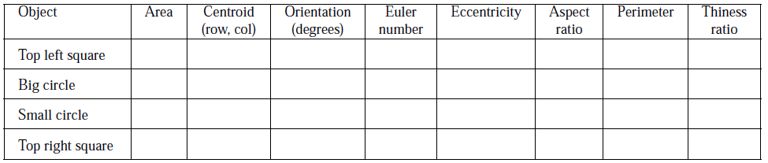
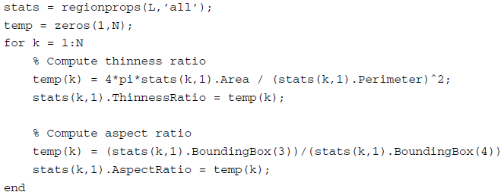
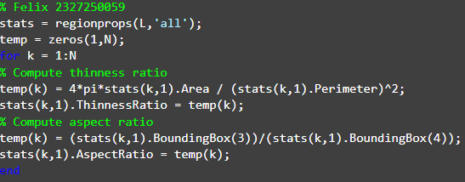
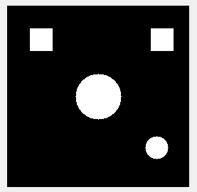

Question 2 Do the results obtained for the extracted features correspond to your expectations? Explain.
ya sudah sesuai dengan apa yang saya harapkan, karena sudah memiliki 4 objek yang sama seperti pada gambar aslinya

Question 3 Which of the extracted features have the best discriminative power to help tell squares from circles? Explain.
Menurut saya kode ini:
temp(k) = 4*pi*stats(k,1).Area / (stats(k,1).Perimeter)^2;
stats(k,1).ThinnessRatio = temp(k);
penjelasan
kode untuk membedakan persegi Panjang adalah kode ini:
temp(k) = 4*pi*stats(k,1).Area / (stats(k,1).Perimeter)^2;
penjelasan
stats(k,1).Area - Luas area objek ke-k dalam piksel kuadrat
stats(k,1).Perimeter - Keliling objek ke-k dalam piksel
kode ini untuk membedakan llingkaran:
stats(k,1).ThinnessRatio = temp(k);

Question 4 Which of the extracted features have the worst discriminative power to help tell squares from circles? Explain.
Kode ini memiliki kode pembeda yang buruk :
temp(k) = (stats(k,1).BoundingBox(3))/(stats(k,1).BoundingBox(4));
stats(k,1).AspectRatio = temp(k);
karena boundingbox mengukur dari tinggi objek sehinggia bila objek di putar tingginya pasti berubah. Dan sulit membedakan yang mana persegi Panjang dan yang mana lingkaran.

Question 5 Which of the extracted features are ST invariant, that is, robust to changes in size and translation? Explain.
Menurut saya kode ini:
temp(k) = 4*pi*stats(k,1).Area / (stats(k,1).Perimeter)^2;
stats(k,1).ThinnessRatio = temp(k);
karena kode ini bekerja dengan cara mengukur area objek. Maka dari itu kode ini sangat aman bila ada perubahan ukuran ataupun translasi.

Question 6 If you had to use only one feature to distinguish squares from circles, in a ST-invariant way, which feature would you use? Why?
Menurut saya kode ini:
temp(k) = 4*pi*stats(k,1).Area / (stats(k,1).Perimeter)^2;
stats(k,1).ThinnessRatio = temp(k);
karena kode ini tergantung dengan ST dan juga sangat aman bila objek terotasi.

- Plot the 2D feature vectors obtained using the area and thinness ratio of each object.
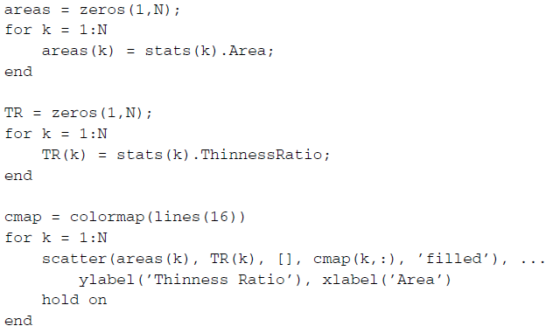
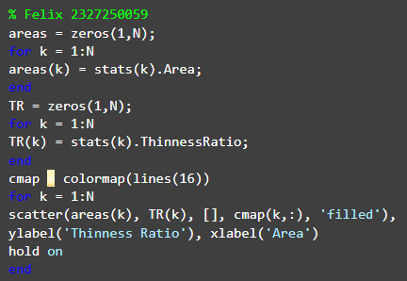
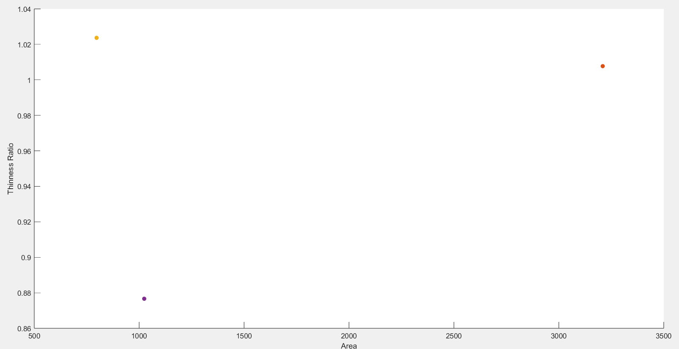

- Repeat steps 1–6 for a different test image, Test3.png (Figure 22.1b).
- Write MATLAB code to implement a heuristic three-class classifier capable of discriminating squares from circles from unknown shapes. Hints: Use a subset of features with enough discriminative power and encode your solution using if-else-if statements. Use the code snippet below to get started.
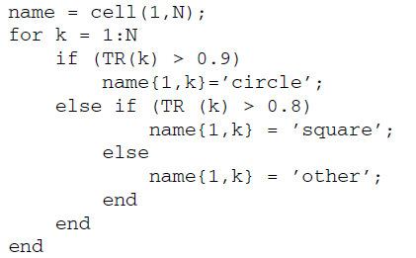
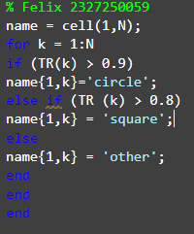

- Test your solution using the TPTest1.png and Test3.png test images.
- Test your solution using different test images.
- Extend your classifier to be able to process color images, for example, shapes23.png (Figure 22.1).

